Project By:

# Eng/Tarik Ahmed Lotfy.

Required Algorithms For Finding MST Using Kruskal’s Algorithm

# Input:

- A graph G(V,E) where V is the set of vertices and E is the set of edges with weights.

# Output:

- Minimum Spanning Tree T (a set of edges).

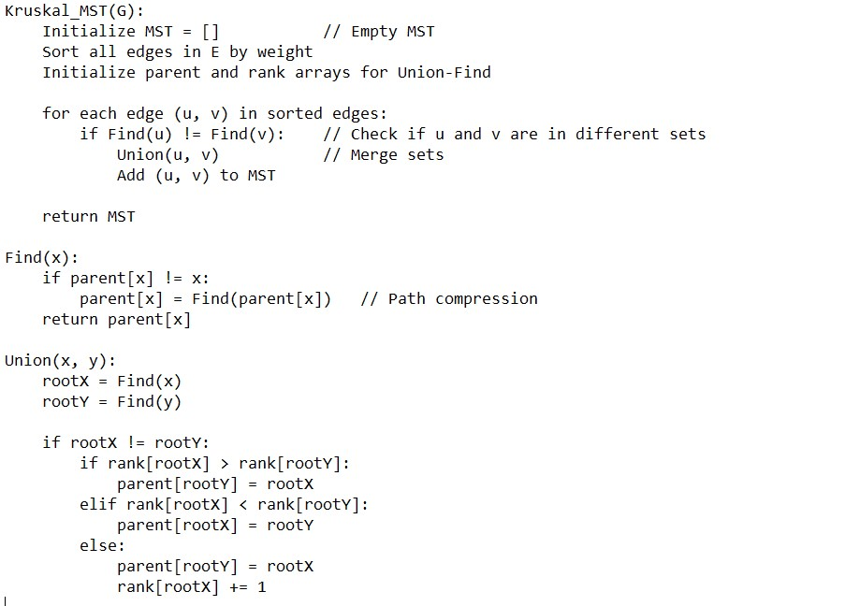

==================================================

Analysis of Algorithm (Time Complexity)

**1-Sorting the Edges**:

-Time Complexity: O(E log E), where E is the number of edges.

-Sorting dominates the overall time complexity.

**2-Union-Find Operations**:

- Using **Path Compression** and **Union by Rank**, each find and union operation has an **amortized time complexity** of O(α(V)), where α is the inverse Ackermann function (very small constant).

**3- Iterating Through Edges**:

-Each edge is processed once: O(E).

# **Overall Time Complexity**:

* O(E log E + E . α(V))
* Since α(V) is very small, the time complexity simplifies to O(E log E).